WELDLESS THERMOMETER COUPLING / THERMOMETER INSTALLATION INSTRUCTIONS

- Locate the thermometer coupling hardware in your packaging – this fits up into the top hole on the kettle. You will of course need to remove the weldless plug that is in there now.
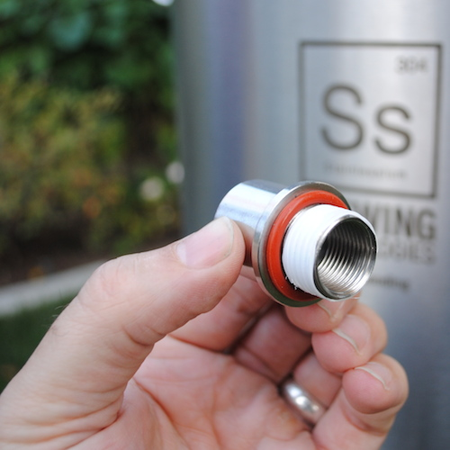
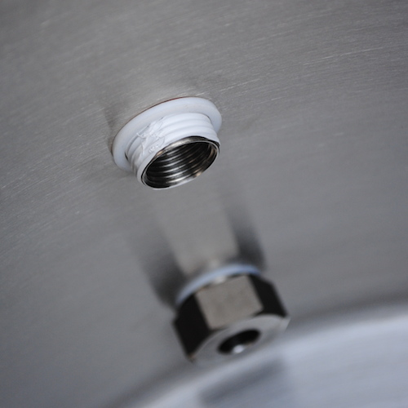
- Follow the assembly steps in the pics below and don’t forget to use some Teflon tape for best sealing! Make sure the o-ring is fitted on to the threaded part of the coupling and seats up into the recess. The o-ring goes on the outside of kettle and the white washer goes on the inside. Use a crescent wrench to tighten up after you have the locking nut on finger tight.

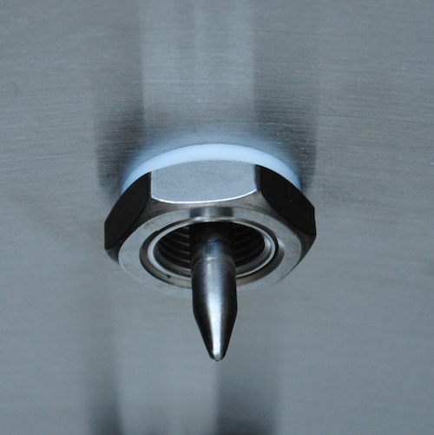
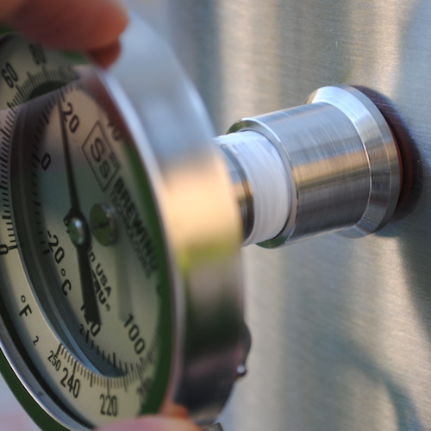

REMINDER: ALWAYS CLEAN/SANITIZE YOUR PARTS AND LEAK TEST BEFORE USE!!!

