Keyence Ultrasonic Flow Meter

The meter is located on the OUTPUT leg of the Mash Tun.
It is useful to monitor the Flow Rate and Total Volume transferred to the Kettle
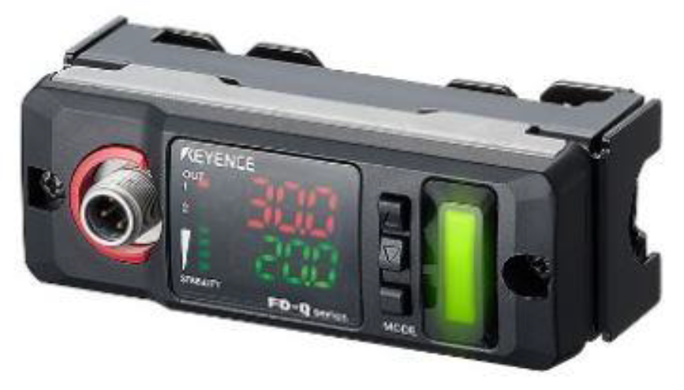
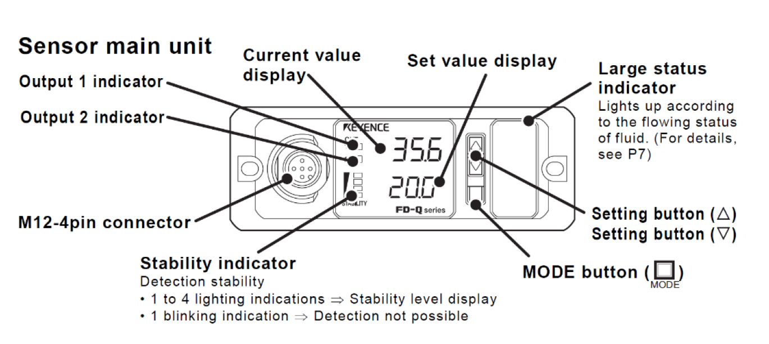
The meter has been calibrated at the factory, however if you notice a different in volume transferred when compared to the meter – you can calibrate the SPAN of the meter. See Calibration Section.
The Upper RED display is the Current Value Display. This is the one you will use. The lower Green Display is for Set-Points, and is NOT used in your system.
The Output 1 and 2 Indicators are NOT used in your system. They may turn on or off from time to time but will have no affect on the meters operation.
While in operation, the Stability display should show 3-4 bars illuminated. This indicates the pipe is full of liquid and proper measurements are possible.

Normal Operation
SHORT Press the MODE Button to change between;
Flow Rate
- Short press MODE until you see “0.0”
Total Volume
- Short press MODE until you see “ttL”
- To Reset, Press and HOLD both Up/Down buttons for several seconds.
Hold
- During operation, the Max and Min Flow Rates are stored.
- Short pressing the MODE button until you see “HoLd”
- To Reset, Press and HOLD both Up/Down buttons for several seconds
Calibration Setting
Long Press the MODE Button to enter the Setup Menu
Repeatedly short press MODE to locate the screen SPAn Screen
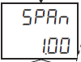
Setting a new calibration factor.
- Press the Up or Down arrows to change the Calibration factor.
- Pressing Up has the effect causing the display to read a larger value for a give volume of fluid.
- Pressing Down has the effect causing the display to show a smaller value for a given volume of fluid.
NOTE: The first several gallons of liquid will not provide an accurate reading. During this time the meter is performing auto-tuning. Always use 30 or more gallons to determine a new calibration factor.
After a new calibration factor is set, short press MODE to locate the “END” screen
Then, Long Press MODE to save the settings.

Additional Setting
For additional setting please refer to the Keyence Manual

